**Employee Database**

**Question**

**(Week 05)**

1. Using Scheme diagram, Create tables by properly specifying the primary keys and the foreign keys.

2. Enter greater than five tuples for each table.

3. Retrieve the employee numbers of all employees who work on project located in Bengaluru, Hyderabad, or Mysuru

4. Get Employee ID’s of those employees who didn’t receive incentives

5. Write a SQL query to find the employees name, number, dept, job_role, department location and project location who are working for a project location same as his/her department location.

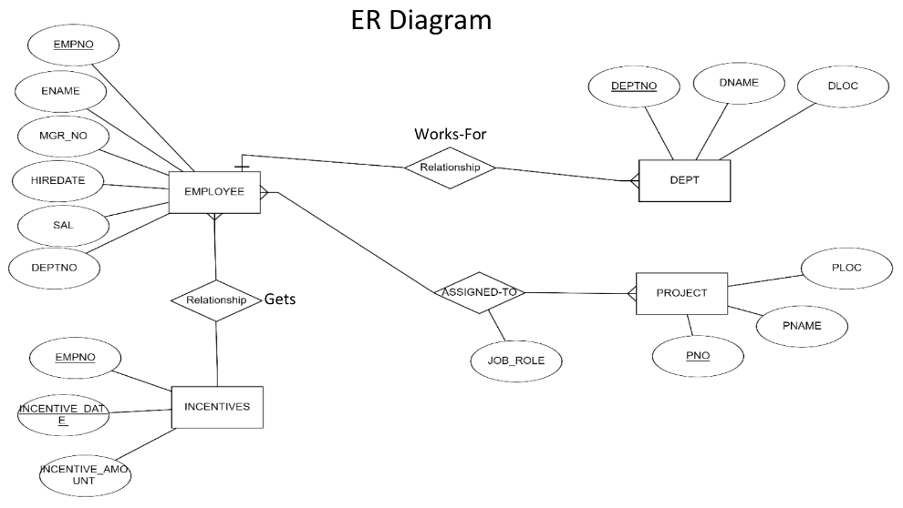

**Create database**

create database employee_402;

use employee_402;

**Create tables**

**create table** dept (

deptno int **primary key**,

dname varchar(50),

dloc varchar(50)

);

**create table** employee (

empno int **primary key,**

ename varchar(50),

mgr_no int,

hiredate date,

sal int,

deptno int,

**foreign key** (deptno) **references** dept(deptno)

);

**create table** project (

pno int **primary key,**

ploc varchar(50),

pname varchar(50)

);

**create table** assigned_to (

empno int,

pno int,

job_role varchar(50),

**primary key** (empno, pno),

**foreign key** (empno) **references** employee(empno),

**foreign key** (pno) **references** project(pno)

);

**create table** incentives (

empno int,

incentive_date date,

incentive_amount int,

**foreign key** (empno) **references** employee(empno));

**Department table :**

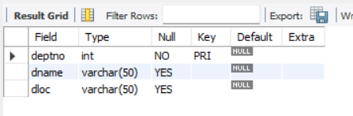

**Employee Table :**

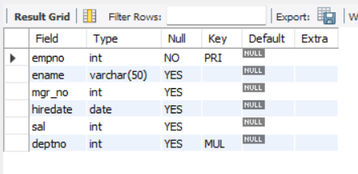

**Project table :**

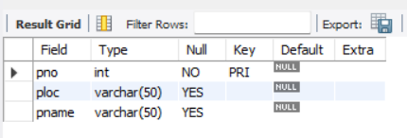

**Assigned_to table :**

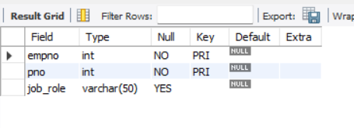

**Incentive table:**

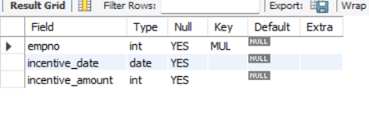

**Inserting the values to the tables**

insert into dept values(10,'sales','bengaluru');

insert into dept values(20,'marketing','hyderbad');

insert into dept values(30,'finance','mysuru');

insert into dept values(40,'HR','bengaluru');

insert into dept values(50,'IT','hyderbad');

select * from dept;

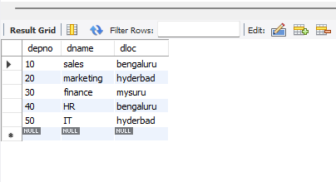

insert into employee values(1,'alice',2,'2022-01-01',55000,10);

insert into employee values(2,'bob',3,'2023-04-05',68000,20);

insert into employee values(3,'charlie',1,'2025-06-11',23000,10);

insert into employee values(4,'david',2,'2022-03-01',55800,20);

insert into employee values(5,'emily',null,'2022-04-11',67800,10);

select * from employee;

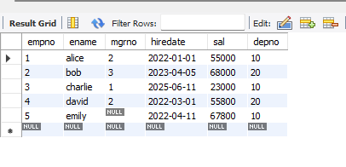

insert into project values(1,'e-learning','bengaluru');

insert into project values(2,'hostel management','hyderbad');

insert into project values(3,'hotel management','bengaluru');

insert into project values(4,'face recognition','chennai');

insert into project values(5,'face emotion recognition','mysuru');

select * from project;

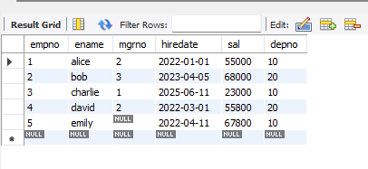

insert into assignment values(1,1,'manager');

insert into assignment values(2,2,'team lead');

insert into assignment values(3,1,'analyst');

insert into assignment values(4,2,'developer');

insert into assignment values(5,3,'tester');

select * from assignment;

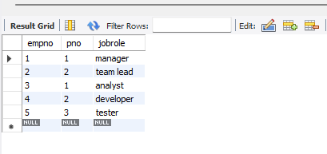

insert into incentives values(1,'2022-11-10',5000);

insert into incentives values(2,'2023-12-10',5000);

insert into incentives values(3,'2024-12-10',5000);

insert into incentives values(4,'2022-10-10',5000);

select * from incentives;

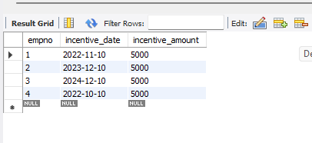

**Queries**

**3 Retrieve the employee numbers of all employees who work on project located in Bengaluru, Hyderabad, or Mysuru.**

**select** empno **from** assignment **where** pno in(select pno **from** project **where** ploc in('bengaluru','mysuru'));

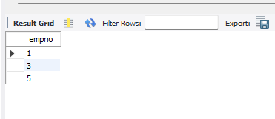

**4 Get Employee ID’s of those employees who didn’t receive incentives**

**select** empno **from** employee **where** empno not in(select empno from incentives);

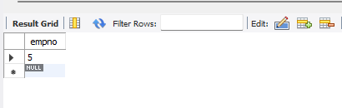

**● Write a SQL query to find the employees name, number, dept, job_role, department location and project location who are working for a project location same as his/her department location.**

**select** e.ename,e.empno, d.dname, a.jobrole, d.dloc as deploc, p.ploc as proloc **from** employee e **join** dept d on e.depno = d.depno join assignment a **on** e.empno = a.empno **join** project p on a.pno=p.pno **where** d.dloc = p.ploc;

